5180
Hanes

Beefy-T
100% Cotton T-Shirt

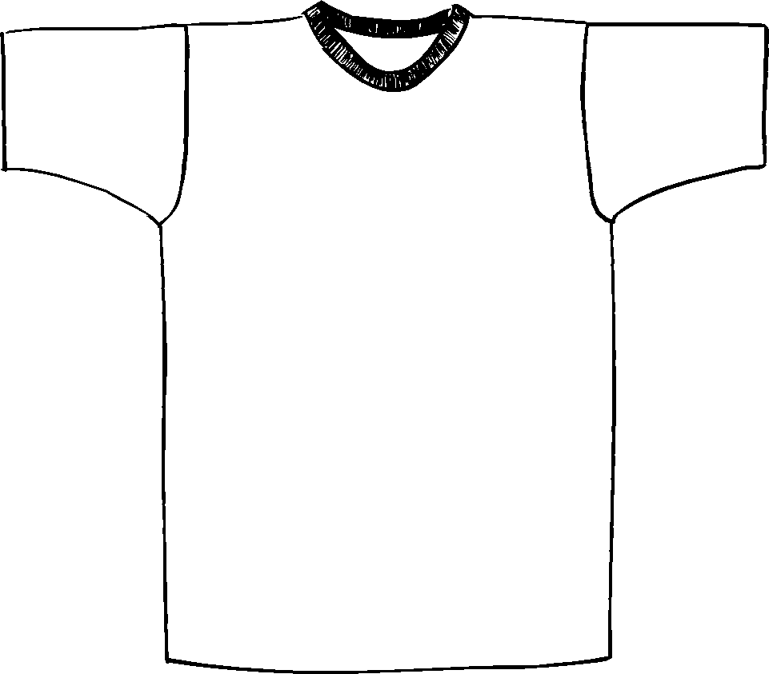

Descriptions
*100% cotton 6.1 ounce
*17 singles
*Ring spun yarn
*Taped shoulder to shoulder
*Coverseamed neck
*Double needle sleeve, bottom hem & neck
*Screenprinting or embroidery okay

Finished Garment Measurements

Size | S | M | L | XL | 2XL | 3XL | 4XL | 5XL | 6XL
Width | 18 | 20 | 22 | 24 | 26 | 28 | 30 | 32 | 34
Length | 28 | 29 | 30 | 31 | 31.5 | 32 | 32.5 | 33 | 33.5
Sleeve from shoulder seam | 7.5 | 8.75 | 8.5 | 8.5 | 8.5 | 8.5 | 8.5 | 8.5 | 8.5

